Types of Modifiers
# Source: AI Source: Provided by: [Data Path: Persons Table -> ID Column: 1, Name_En Column: Motasem Essam] -> From: [Chatgpt (GPT-4-turbo)] on [8/6/2025]
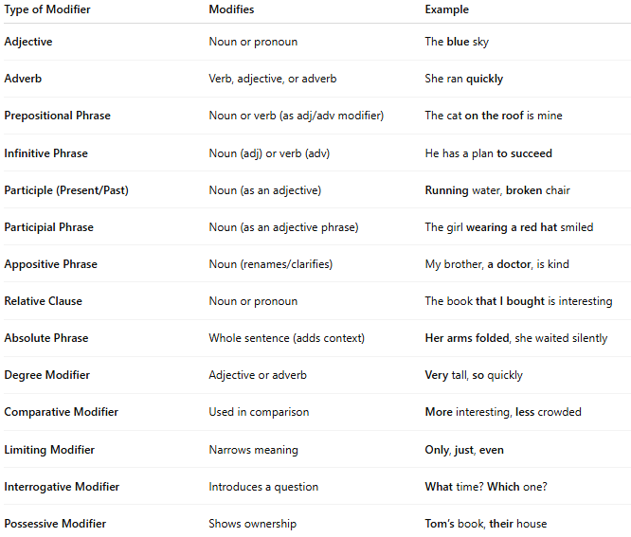

Type of Modifier | Modifies | Example
Adjective | Noun or pronoun | The blue sky
Adverb | Verb, adjective, or adverb | She ran quickly
Prepositional Phrase | Noun or verb (as adj/adv modifier) | The cat on the roof is mine
Infinitive Phrase | Noun (adj) or verb (adv) | He has a plan to succeed
Participle (Present/Past) | Noun (as an adjective) | Running water, broken chair
Participial Phrase | Noun (as an adjective phrase) | The girl wearing a red hat smiled
Appositive Phrase | Noun (renames/clarifies) | My brother, a doctor, is kind
Relative Clause | Noun or pronoun | The book that I bought is interesting
Absolute Phrase | Whole sentence (adds context) | Her arms folded, she waited silently
Degree Modifier | Adjective or adverb | Very tall, so quickly
Comparative Modifier | Used in comparison | More interesting, less crowded
Limiting Modifier | Narrows meaning | Only, just, even
Interrogative Modifier | Introduces a question | What time? Which one?
Possessive Modifier | Shows ownership | Tom’s book, their house

